| **Test Name** | | Add Patient Type to System | | | |
| --- | --- | --- | --- | --- | --- |
| **Use Case Tested:** | | Use Case - Add Patient Type to System | | | |
| **Test Description:** | | User needs to add a new patient type  User navigates to Manage Patient Types tab.  User is presented with a blank form to add the new patient type details.  User enters the required information  User submits form | | | |
| **Pre-conditions** | | Patient must not exist in the system | | | |
| **Post-conditions** | | The database is successfully updated with the new data for the Patient Type. | | | |
| **Notes:** | |  | | | |
| **Result (Pass/Fail/Warning/Incomplete)** | |  | | | |
|  | **TEST STEP** | | **EXPECTED TEST RESULTS** | P | F |
|  | User selects “Search > Manage Patient Types” from the menu bar or selects Manage Patient Types button on Admin Home page | | A blank Patient Types Details form appears – using Button  A blank Patient Types Details form appears – using Menu Bar | X  X |  |
|  | User enters the Patient Type | | Input does not show error | X |  |
|  | User selects Submit button | | Message appears that the record was successfully added | X |  |
|  |  | | Database updated to show new patient type | X |  |

|  |  |  |  |  |  |
| --- | --- | --- | --- | --- | --- |
| **Test Data Table** | | | | | |
|  | **1** | **2** | **3** | **4** | **5** |
| Test – 1 | Another patient type |  |  |  |  |
| Test – |  |  |  |  |  |
| Test – |  |  |  |  |  |
|  |  |  |  |  |  |

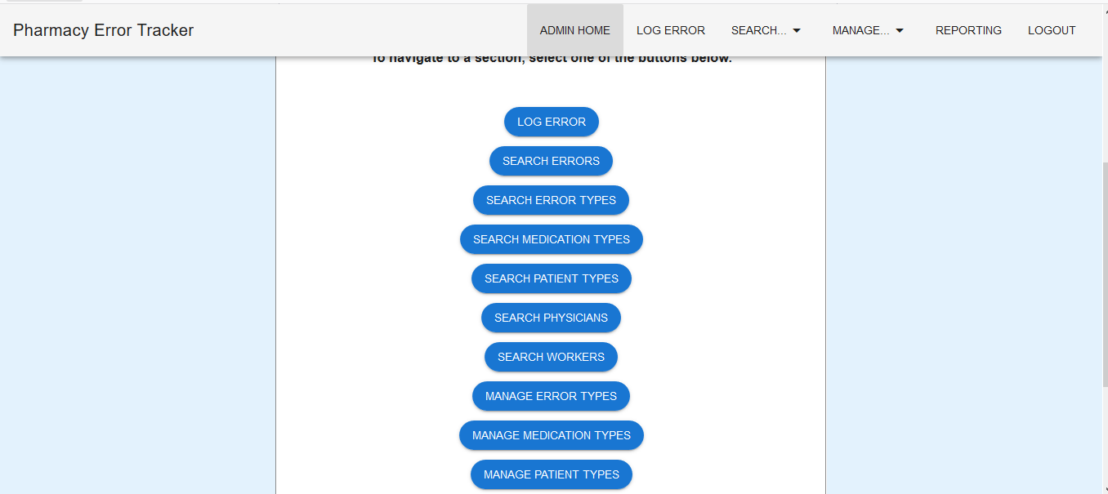

Figure 1: Select Manage Patient Types via Button

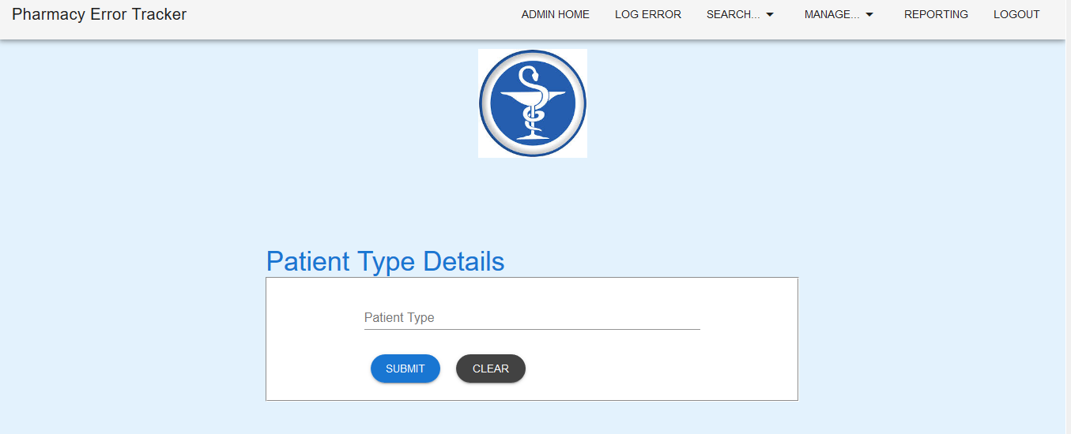

Figure 2: Patient Type Details form is loaded

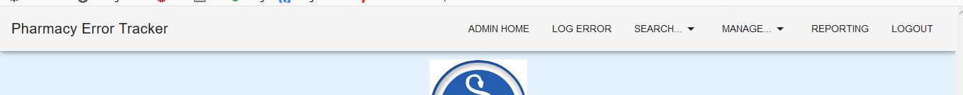

Figure 3: Select Manage Patient Types via Menu Bar

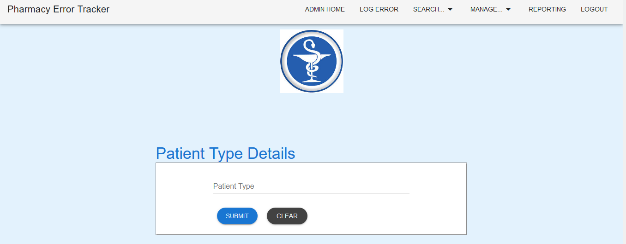

Figure 4: Patient Type Details form is loaded

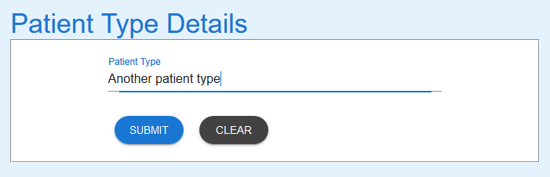

Figure 5: Details entered

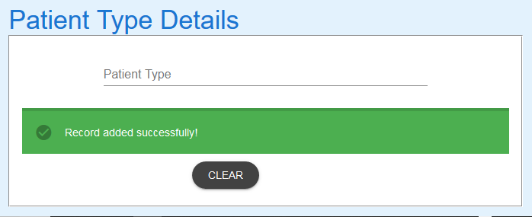

Figure 6: Submit button selected. Success message returned

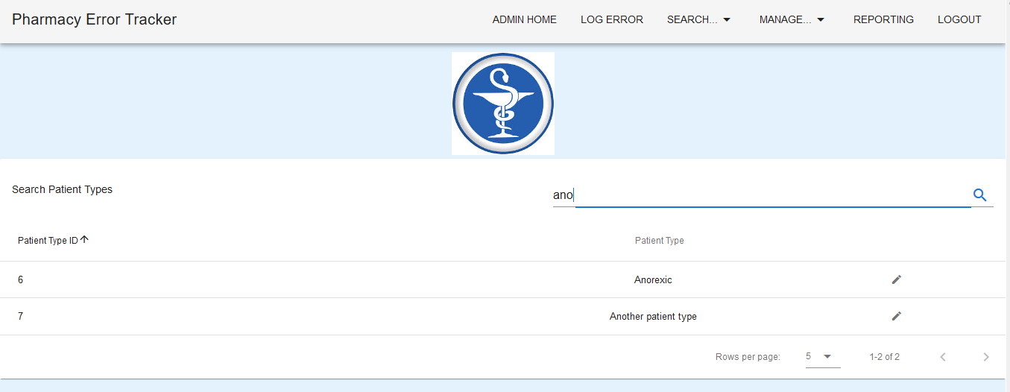

Figure 7: Search for "ano" shows the new patient type has been added to the database

EXPECTED ERRORS:

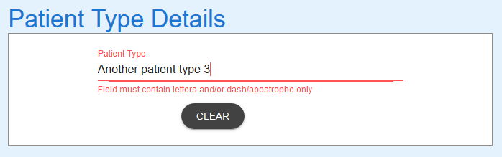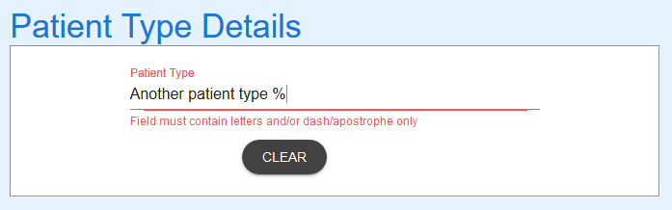

Figure 8: Adding a number or character to description causes error – Expected

EXPECTED BEHAVIOUR

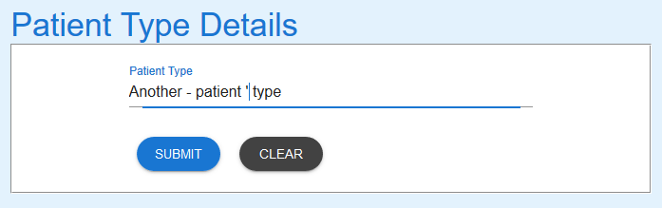

Figure 9: Able to use - and/or ' with spaces and letters - Expected

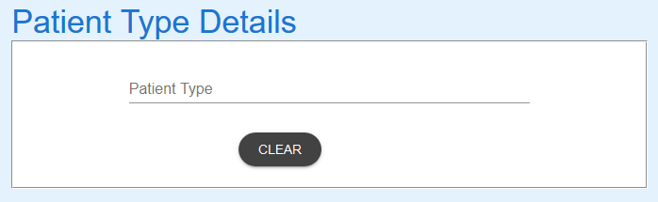

Figure 10: Selecting Clear resets the form - Expected